Port of Kaohsiung
Vessel Traffic Service Manual

Promulgated Dec. 5, 2001
Amended March 5, 2007
Amended Feb. 29, 2012
Amended Feb. 15, 2023

I. General Provisions

Article 1
This Manual has been compiled to strengthen vessel traffic services, to ensure safe and orderly vessel navigation in waterways, to enhance vessel traffic efficiency, to protect the marine environment of surrounding waters, and to protect the safety of vessels, facilities, human life and property.

Article 2
Terms used in this Manual are defined as follows:
Vessel: refers to mechanically propelled vessels of 20 gross tonnage (GT) and above, including merchant ships, naval vessels, work boats, fishing boats, public vessels etc.

The Port of Kaohsiung Vessel Traffic Service Center (hereafter "VTS") is the agency carrying out vessel traffic service operations at the Port of Kaohsiung. It is located at L22°33'13.9N, λ 120°18'56.4" E (WGS84) and called "Kaohsiung VTS".

Vessel Traffic Service Area (VTS Area): refers to the scope of the port area of the Port of Kaohsiung as determined by the Executive Yuan. To facilitate separate services for inbound and outbound vessels passing through the First (North) Harbor Entrance and the Second (South) Harbor Entrance, the area has been divided into the "VTS North Sector" and the "VTS South Sector" by a hypothetical line running from the Chung-Chow wastewater treatment sludge discharge pipe outside the harbor to the Chien-Cheng River inside the harbor.

Vessel Information Service Area (VIS Area): refers to the water area centered at the point of L 22°34'54.8" N, λ 120°17'29" E (WGS84) with a range of 20 nautical miles outside of the VTS Area. Within this area an information exchange service with inbound and outbound vessels has been established to enable the VTS Center to obtain relevant vessel data in advance.

Assigned channels: refers to channels for continuous radio listening watch within the VTS and VIS areas in the very high frequency (VHF) band, including
VTS Area North Sector channel 14 (156.7 MHz),
VTS Area South Sector channel 12 (156.6 MHz),
VIS Area channel 11 (156.55 MHz).

Safe speed: refers to the speed that is appropriate in the current environment and under prevailing conditions for taking appropriate and efficient measures and stopping a vessel within a proper distance to avoid collisions.

Article 3
This Manual applies to all vessels navigating, anchoring/berthing, and operating within the VTS and VIS areas, as well as their owners, operators and agents, masters, and pilots.

II. Vessel Reporting

Article 4
When navigating, anchoring/berthing, and operating within the VTS Area of the Port of Kaohsiung, the following vessels must accept vessel traffic services and begin to report vessel data upon entering the VIS Area:
- Mechanically propelled vessels of GT 500 and above.
- Mechanically propelled vessels of 50 meters in length and above.
- Vessels towing or pushing other vessels in a configuration that totals 500 GT and above, 50 meters in length and above, or 50 meters in tow and above.
- Passenger vessels equipped with VHF radio.
- Any vessel less than 50 meters in length or GT 500 equipped with VHF radio in case of emergency to avoid imminent danger when using appropriate navigation channels or separation zones.

Article 5
The master of the vessel must report the approaching vessel's data to the VTS when in the following positions (see chart for positions, WGS84):
- When crossing the line 20 nautical miles off the VTS of the Port of Kaohsiung.
- When crossing the line 12 nautical miles off the VTS of the Port of Kaohsiung.
- When passing the northern end of the separation zone (L 22°35'30" N, λ 120°10'21" E).
- When passing the southern end of the separation zone (L 22°34'18" N, λ 120°13'06" E).
- When the pilot goes aboard, or at the pilot station of the First (North) Harbor Entrance (L 22°37'21" N, λ 120°13'17" E) (applicable to vessels without pilot aboard).
- When the pilot goes board, or at the pilot station of the Second (South) Harbor Entrance (L 22°32'22" N, λ 120°15'53" E) (applicable to vessels without pilot aboard).
- Before and after anchoring.
- Before and after heaving anchor.
- When passing the estuary of the Chien-Cheng River.
- Before and after docking or undocking (including at mooring buoy)
- Before the outbound vessel enters the two-way traffic route at the First (North) Harbor Entrance. and when dropping off the pilot.
- Before the outbound vessel enters the two-way traffic route at the Second (South) Harbor Entrance, and when dropping off the pilot.
- In case of an emergency.
After the pilot boarded the vessel, vessel data may be reported by the pilot on behalf of the master.

Article 6
When vessels navigate, anchor/berth and operate in the VTS and VIS areas of the Port of Kaohsiung, vessel data must be reported to the VTS via the assigned VHF channels or other effective communication methods.

The first vessel data report must include:
- Ship name and call sign.
- Ship position and port arrival time.
- Ship course.
- Ship speed.
- Port of destination.
- General description of dangerous cargo carried.
- Vessel category.

The second (included) vessel data report must include:
- Ship name.
- Ship position and time of notification.

Article 7
If a vessel is involved in a traffic accident, pollution incident, or other emergency in the VTS and VIS areas of the Port of Kaohsiung, the master of the vessel must immediately take appropriate emergency measures to avert danger and immediately report to the VTS via the assigned VHF channel, as first priority, or other effective communication methods.

Article 8
When a vessel detects anomalies of navigational aids or encounters obstacles such as sandbars, flotsam, reefs, or other new obstructions that may endanger the safety of navigation in the VTS and VIS areas of the Port of Kaohsiung, a report must be made promptly to the VTS.

Article 9
When the master or pilot deviates from relevant articles in this Manual to prevent endangering human life/property or environmental safety, the master or pilot must immediately report to the VTS.

Article 10
English is the primary language and Chinese Mandarin is the secondary language used for communication between vessels and the VTS of the Port of Kaohsiung via the assigned VHF channels.

III. Vessel Traffic Administration

Article 11
Vessels navigating in the VTS Area must abide by relevant provisions in the Convention on the International Regulations for Preventing Collisions at Sea 1972 (COLREGs) and provisions with respect to navigation and prevention of collisions provided in the Commercial Port Law and The Regulations on Port Services at Commercial Ports.

Article 12
Inside the VTS Area vessels must proceed with safe speed.

Article 13
Inside the VTS Area vessels must anchor in designated anchorage areas.

Article 14
Except for emergency situations, vessels must not drop anchor in navigation channels, turning basins, or other areas where anchoring is prohibited. The emergency situations in the foregoing paragraph must be immediately reported to the VTS.

Article 15
When a vessel drops anchor due to an emergency or poor visibility it must display light and shape signals, use sound signals, and report immediately to the VTS.

Article 16
Vessels navigating in the harbor area of the Port of Kaohsiung must pay attention to harbor area announcements, the navigation channel's surroundings, the weather etc. They must proceed with safe speed, not sail side by side with other vessels nor randomly overtake other vessels or interfere with their safe navigation. This does not apply when following instructions from the VTS. Vessels must immediately give way or pass at slow speed when meeting other vessels engaged in diving / surveying / dredging / mooring buoy repair activities, and other overwater and underwater operations.

Article 17
When two vessels plan to anchor side by side in the anchorage areas, they must report to the VTS in advance and obtain prior approval from the Kaohsiung branch of the Taiwan International Ports Corporation, Ltd. for ship-to-ship transfer operations.

Article 18
Vessels entering or leaving port must apply in advance for traffic arrangements with the VTS, and they must enter and leave the port in the right order as arranged by the VTS.
The VTS may make adjustments or changes to a vessel's port entering, port leaving and anchoring plan, based on the actual circumstances.

Article 19
Vessels navigating, anchoring/berthing, or operating in the VTS Area must maintain continuous listening watch on the assigned channel and must not abuse radio channels for chatting. They must respond to questions from the VTS.

IV. Vessel Traffic Services

Article 20
Upon request from vessels, the VTS shall provide relevant information services, including the data of other vessels in the VTS Area, the condition of navigational aids, hydrometeorological conditions, navigational warnings etc.

Article 21
The VTS may provide information or warnings to vessels to prevent dangerous maritime traffic situations.

Article 22
Regarding the provisions in Articles 20 and 21, the master or pilot still bears legal responsibility for carrying out their official duties.

V. Vessel Navigation

Article 23
This Manual is applied in waters with a traffic separation scheme (TSS). Vessels must follow the proper TSS traffic lane as shown in Appendix 1. Vessels must follow the route indicated by navigational markers when navigating outside of TSS waters.

Article 24
Vessels navigating in waters where this Manual applies must maintain a safe under keel clearance of at least 0.5 meters.

Article 25
In the two-way traffic route, vessels are prohibited from overtaking one another. In other channels, vessels can be overtaken only after the VTS has given such instructions.

Article 26
When navigating in the same channel, smaller vessels must not interfere with the safe navigation of larger vessels.

Article 27
When two vessels are at risk of collision, the vessel navigating outside the channel is responsible for giving way to the vessel navigating inside the channel.

Article 28
(Deleted)

VI. Anchoring and Berthing

Article 29
Inside the Port of Kaohsiung vessels shall be limited to anchoring in the anchorage areas specified in Appendix II of this Manual. Anchoring outside said areas is prohibited. Vessels are not allowed to drop anchor beyond the boundaries of the anchorage areas under any circumstances.

Article 30
Vessels planning to enter an anchorage area to drop anchor must contact the VTS when 20 nautical miles away from the port via the assigned VHF radio channel (Channel 11) and apply for an anchoring position.
Within ten minutes before and after dropping or heaving anchor vessels must report their data to the VTS. While vessels are at anchor, a specially assigned person must maintain listening watch on the assigned VHF radio channel (Channel 11).

Article 31
Vessels at anchor/in berth must keep engines standby at day and at night. At least one third of the full crew of the deck and engine departments is to be kept on board, each with an officer in charge. When a typhoon warning has been issued, the master must allocate additional crew to ensure the ability to maneuver the vessel during navigation, and to respond in an emergency.

Article 32
Vessels must take precautions based on their ability to withstand wind, and in periods of strong gusting winds follow the unified instructions of the VTS. After a typhoon warning has been issued for the waters near the Port of Kaohsiung, vessels at anchor in the anchorage areas must tighten their vigil in line with relevant provisions to respond to emergencies.

VII. Traffic Services

Article 33
All vessel traffic, be it vessels navigating or anchoring/berthing within the waters of the VTS Area of the Port of Kaohsiung, must listen to the navigational safety information or instructions provided by the VTS.

Article 34
For safety purposes, the VTS may take special safety measures for vessels that experience difficulties maneuvering or that carry dangerous chemicals in bulk or other inflammable/explosive cargoes.
The VTS may take necessary mandatory measures when a vessel or facility is involved in an accident or out of control, and threatens to endanger, or endangers traffic safety and the aquatic environment.

Article 35
Dockyard operators must report docking/undocking plans to the VTS one hour before a vessel docks or undocks.

Article 36
Vessels must listen to the safety information broadcasts by the VTS on time.

VIII. Others

Article 37
Vessels temporarily drifting outside the harbor while waiting for a berth must drift 10 nautical miles outside the port and must not wander into the TSS area and the anchorage areas. They must also report to the VTS.

Article 38
Fishing and setting up fishing nets is strictly prohibited in channels, TSS lanes, anchorage areas, dredging zones, and wharf-side waters.

Article 39
The Pilot Office must report the planned sequence of pilot operations to the VTS in advance. Pilot operations are to be conducted in the area approved by the VTS. Vessels picking up or dropping off a pilot must do so in the designated area. Any deviation from the approved area (e.g., due to bad weather) must be reported to the VTS.

Article 40
Vessels adjusting compasses in the VTS area must report to the VTS in advance, and comply with the following provisions:
- While adjusting compasses vessels must vertically display international signal flags with the code "OQ".
- Vessels must not calibrate compasses in the TSS area and the anchorage areas and must not interfere with the regular navigation of other vessels.

Article 41
Vessels undergoing speed trials in the VTS area must report to the VTS in advance, and comply with the following provisions:
- When undergoing speed trials vessels must vertically display the international signal flag code "SM".
- Vessels undergoing speed trials must notify passing vessels via the assigned VHF channel about their data and exchange maneuvering information while enhancing look-out activities and maneuvering carefully.

Article 42
Vessels carrying out towing operations must apply for prior approval with the competent authorities and the port administration agencies responsible for the respective operations, based on the towed object (such as vessel, float etc.). The approved documents must be faxed to the VTS one hour before departure or arrival for the vessel's release.
Towing operations must be carried out between sunrise and sunset.

Article 43
Vessels carrying out maneuvering trials within the VTS Area of the Port of Kaohsiung must transmit a report to the VTS.
When carrying out maneuvering trials, international maritime signal flags with the code "RU1" must be displayed vertically at day, and three round signal lights in white, green, and red must be lit vertically at night.
Anchoring trials must be reported to the VTS in advance.
Vessels conducting anchoring trials must inform passing vessels via the assigned VHF channel of their data and exchange maneuvering information while enhancing look-out activities and maneuvering carefully.

Article 44
This Manual is implemented on the date of promulgation.

Annex I:
THE TRAFFIC SEPARATION SCHEMES OF
THE PORT OF KAOSHIUNG (WGS84)
Part I: First (North) Harbor Entrance Channel
- TSS area (separate navigation lanes, vessels sail in the direction indicated by the arrows)
  - The separation line is formed by the line between the two following points:
ATON F1 | 22°37'38"N, 120°13'22"E
ATON F2 | 22°37'52"N, 120°12'19"E
  - Outbound channel: The waters between the separation line and the line connecting the two following points:
A3 | 22°38'40"N, 120°12'40"E
A4 | 22°38'12"N, 120°13'35"E
  - Inbound channel: The waters between the separation line and the line connecting the two following points:
B3 | 22°37'02"N, 120°13'17"E
B4 | 22°37'00"N, 120°12'10"E

- Two-way traffic route area (incoming and outgoing directions are controlled by the VTS controller. Before encountering or overtaking other vessels permission must be obtained from the VTS.)
  - The northern boundary is formed by the line connecting the two following points:
A4 | 22°38'12"N, 120°13'35"E
A5 | 22°37'15"N, 120°15'25"E
  - The southern boundary is formed by the line connecting the two following points:
B1 | 22°37'04"N, 120°15'23"E
B3 | 22°37'02"N, 120°13'17"E

- Pilot station (The following applies to the data reporting of vessels that do not hire a pilot):
P1 | 22°37'21"N, 120°13'17"E

- Pilot boarding area (area where incoming vessels take pilot aboard): waters bounded by the connecting lines between the following four points:
(1.5-2.5 nautical miles)
22°37'31"N, 120°13'48"E
22°37'02"N, 120°13'45"E
22°37'01"N, 120°12'41"E
22°37'46"N, 120°12'46"E

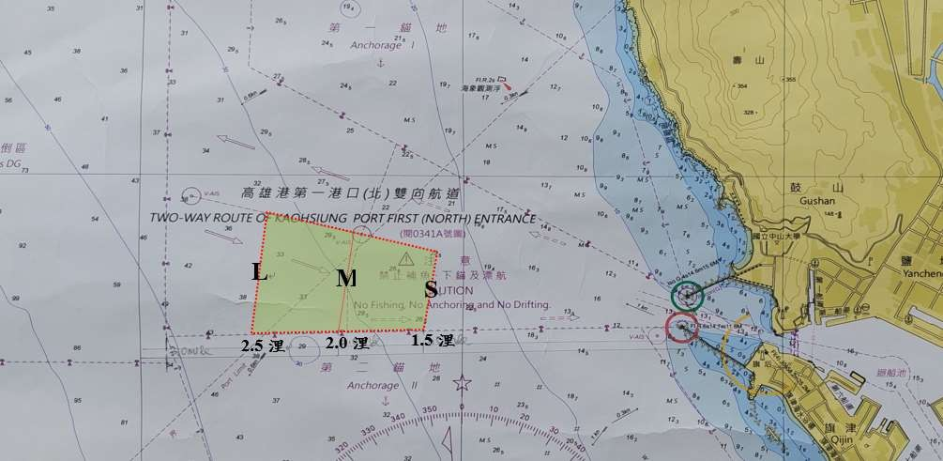

The pilot boarding areas were newly added, based on the comparison table (see table below) of pilot boarding areas for the three categories large, small/medium vessels, and fishing boats, provided by the Maritime and Port Bureau under the Ministry of Transportation and Communications at the Meeting to Promote Pilot Boarding Areas at the Port of Kaohsiung on Nov. 15, 2022. Inside the different areas pilots decide the point of boarding themselves, based on sea conditions and other factors.

Category | Vessel type |  |  |  | Boarding area | Number of pilots
Category | Bulk carrier | Oil/chemical tanker | Container ship | Ultra large vessels for offshore wind parks | Boarding area | Number of pilots
L  Category 1 (large vessels) | Capesize 50000 GT or more | 40000 GT or more | 100000 GT or more | Length of 100 m or more | 2.5 nautical miles | Note 1
M  Category 2 (small and medium vessels) | Less than 50000 GT | Less than 40000 GT | Less than 100000 GT | Length of less than 100 m | 2.0 nautical miles | 1
S  Category 3  (fishing boats, tug boats, workboats. and other small vessels (less than 500 GT)) | – | – | – | – | 1.5 nautical miles | 1
Note 1: must hire a second pilot. Container ships entering or leaving the Phase 2 Terminal of the Kaohsiung International Container Terminal (ICT), that are larger than 100000 GT but have a single-island design, do not need to hire a second pilot, provided the shipping company, the master, and the pilot can guarantee navigational safety.

Note 2: Container ships entering or leaving the Phase 2 Terminal of the Kaohsiung International Container Terminal (ICT), that are larger than 180000 GT must be guided by a pilot from 2.5 nautical miles outside the area limits to ensure safe navigation.

Part II: Channels at the Second (South) Harbor Entrance
- TSS area (separate navigation lanes, vessels sail in the direction indicated by the arrows)
  - The separation line is formed by the line connecting the two following points:
ATON S1 | 22°32'37"N, 120°15'49"E
ATON S2 | 22°32'15"N, 120°13'55"E

  - Outbound channel: The waters between the separation line and the line connecting the two following points:
C3 | 22°33'00"N, 120°13'30"E
C4 | 22°33'02"N, 120°15'44"E
  - Inbound channel: The waters between the separation line and the line connecting the two following points:
D2 | 22°32'10"N, 120°16'00"E
D3 | 22°31'34"N, 120°14'19"E

- Two-way traffic route area (incoming and outgoing directions are controlled by the VTS controller. Before encountering or overtaking other vessels permission must be obtained from the VTS.)
  - The northern boundary is formed by the line connecting the two following points:
C4 | 22°33'02"N, 120°15'44"E
C6 | 22°33'04"N, 120°18'03"E
  - The southern boundary is formed by the line connecting the two following points:
D1¹ | 22°32'38"N, 120°17'19"E
D2 | 22°32'10"N, 120°16'00"E

- Pilot station (The following applies to data reporting of vessels that do not hire a pilot):
P2 | 22°32'22" N, 120°15'53"E

- Second (South) Harbor Entrance pilot boarding area (area where incoming vessels take the pilot aboard): waters delimited by the connecting lines between the following four points (1.5-2.5 nautical miles):
22°32'45"N, 120°16'28"E
22°32'22"N, 120°16'37"E
22°32'02"N, 120°15'37"E
22°32'32"N, 120°15'26"E

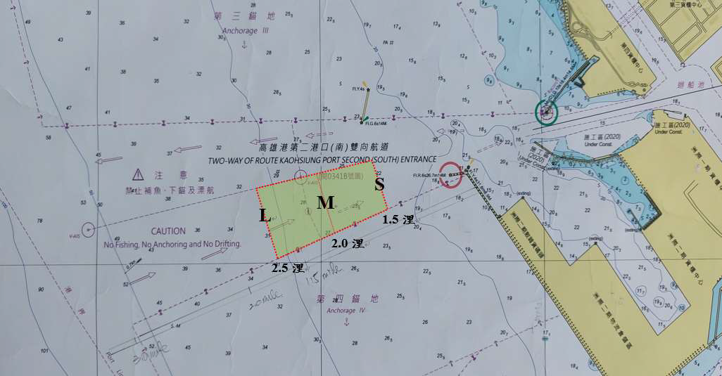

- ICT Pilot boarding area (area where incoming vessels take the pilot aboard): waters delimited by the connecting lines between the following four points (1.5-2.5 nautical miles):
22°32'34"N, 120°15'34"E
22°32'03"N, 120°15'40"E
22°31'41"N, 120°14'40"E
22°32'22"N, 120°14'30"E
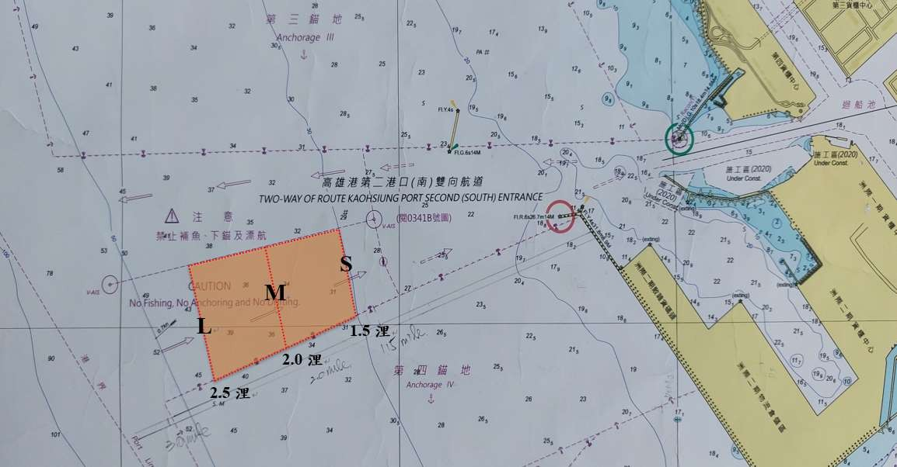

Part III: TSS area on the west side of the anchorage areas (separate navigation lanes, vessels sail in the direction indicated by the arrows)
  - Separation zone: waters bounded by the connecting lines between the following four points:
R1 | 22°35'30"N, 120°11'48"E
R2 | 22°35'30" N, 120°11'12" E
R3 | 22°34'18" N, 120°11'39" E
R4 | 22°34'18" N, 120°12'16" E
  - Southbound channel: The waters between the separation line and the line connecting the two following points:
R5 | 22°35'30" N, 120°10'21" E
R6 | 22°34'18" N, 120°10'47" E
  - Northbound channel: The waters between the separation line and the line connecting the two following points:
R7 | 22°35'30" N, 120°12'41" E
R8 | 22°34'18" N, 120°13'06" E

Navigation Manual

First (North) Entrance Channels
- The two-way traffic route begins at the Kaohsiung Lighthouse and has a length of 2.5 nautical miles. Its northern boundary extends outward in direction 300 degrees from the light pole at the tip of the northern breakwater and the southern boundary extends outward in direction 270 degrees from the light pole at the tip of the southern breakwater.
- The TSS connects with the two-way traffic route. The northern boundary of the TSS outbound channel extends in direction 300 degrees from the light pole at the tip of the northern breakwater to the northern end of the two-way traffic route for a length of 1 nautical mile, measured from the end of the two-way traffic route. The southern boundary of the TSS inbound channel extends outward in direction 270 degrees from the light pole at the tip of the southern breakwater to the southern end of the two-way traffic route for a length of 1 nautical mile, measured from the end of the two-way traffic route. In the middle a separation line divides the inbound and outbound traffic flows. The separation line extends outward in direction 285 degrees from the center point on the curved outer edge of the two-way route for a length of 1 nautical mile.
- The pilot boarding area is located at the meeting-point of the inbound channel and the two-way route at a distance of 1.5-2.5 nautical miles from the southern breakwater at the First (North) Harbor Entrance.

Second (South) Entrance Channels
- The two-way route has a length of 3 nautical miles, measured from the VTS tower. Its northern boundary extends outward in direction 270 degrees from the light pole at the tip of the northern breakwater and the southern boundary extends outward in direction 250 degrees from the light pole at the tip of the southern breakwater.
- The northern boundary of the TSS outbound channel extends outward in direction 270 degrees from the light pole at the tip of the northern breakwater to the northern end of the two-way traffic route for a length of 2 nautical miles, measured from the end of the two-way traffic route. The southern boundary of the TSS inbound channel extends outward in direction 250 degrees from the light pole at the tip of the southern breakwater to the southern end of the two-way traffic route for a length of 1.7 nautical miles, measured from the end of the two-way traffic route.
In the middle a separation line divides the inbound and outbound traffic flows. The separation line extends outward in direction 260 degrees from the center point on the curved outer edge of the two-way route for a length of 1.8 nautical miles.
- The Second (South) Harbor Entrance pilot boarding area is located at the meeting-point of the inbound channel and the two-way traffic route at a distance of 1.5-2.5 nautical miles from the northern breakwater at the Second (South) Harbor Entrance:
The ICT pilot boarding area is located at the meeting-point of the inbound channel and the two-way traffic route at a distance of about 1.5-2.5 nautical miles from the light pole at the ICT southern breakwater.

Anchorage Area West Side Channel
- The northbound channel is 0.8 nautical miles wide and 1.2 nautical miles long and runs in direction 343 degrees.
- The southbound channel is 0.8 nautical miles wide and 1.2 nautical miles long and runs in direction 163 degrees.
- The separation zone has a width of 0.5 nautical miles.
Annex II:
Location of Anchorage Areas outside the Port of Kaohsiung (WGS84)

- First anchorage area:
- Area limits: the waters bounded by the lines connecting the following four points in the given order:
A1 | 22°38'36"N, 120°14'59"E
A2 | 22°39'54"N, 120°12'42"E
A3 | 22°38'40"N, 120°12'40"E
A5 | 22°37'15"N, 120°15'25"E
- Use: backup anchorage area for small and medium vessels entering via the First (North) Entrance and/ dangerous cargo carriers.

- Second anchorage area
- Area limits: the waters bounded by the lines connecting the following four points in the given order:
B2 | 22°37'04"N, 120°15'07"E
B4 | 22°37'00"N, 120°12'10"E
R7 | 22°35'30"N, 120°12'41"E
B5 | 22°35'30"N, 120°16'13"E
- Use: anchorage area for vessels entering and leaving via the First (North) Entrance (excluding dangerous cargo carriers)

- Third anchorage area
- Area limits: the waters bounded by the lines connecting the following seven points in the given order:

C1 | 22°34'18"N, 120°15'47"E
C2 | 22°34'18"N, 120°13'06"E
C3 | 22°33'00"N, 120°13'30"E
C5 | 22°33'04"N, 120°17'46"E
T4 | 22°34'43"N, 120°16'45"E
T3 | 22°34'02"N, 120°15'48"E
T2 | 22°34'13"N, 120°15'40"E
- Use: anchorage area for vessels entering and leaving via the Second (South) Harbor Entrance (excluding dangerous cargo carriers).

- Fourth anchorage area
- Area limits: the waters bounded by the lines connecting the following four points in the given order:
D1¹ | 22°32'38"N, 120°17'19"E
D3 | 22°31'34"N, 120°14'19"E
D4 | 22°30'30"N, 120°14'59"E
D5¹ | 22°31'37"N, 120°18'08"E
- Use: anchorage area for large bulk carriers entering or leaving via the Second (South) Harbor Entrance and backup anchorage area for dangerous cargo carriers.
- Special anchorage area for dangerous cargo carriers
- Area limits: the waters bounded by the lines connecting the following 5 points in the given order:
R7 | 22°35'30"N, 120°12'41"E
B5 | 22°35'30"N, 120°16'13"E
B6 | 22°34'54"N, 120°16'38"E
C1 | 22°34'18"N, 120°15'47"E
C2 | 22°34'18"N, 120°13'06"E
- Use: exclusively for the anchoring of dangerous goods carriers, other vessels are not allowed to enter.

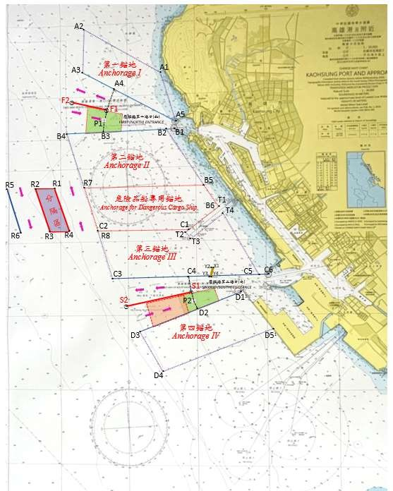
Layout of the Traffic Separation Schemes and Anchorage Areas at the Port of Kaohsiung (WGS84)

Source of chart: published Dec. 25, 2020, by Naval Meteorological & Oceanographic Office, R.O.C. (Chart No. 0341/9th edition)

Pilot Boarding Area at the First (North) Harbor Entrance and Second (South) Harbor Entrance
ICT Pilot boarding area

